**CWT SCRIPT ASSISTANCE**

CWT Script Assistance is a web-based tool that will be used to enable Travel and Tours consultants’ to capture Itinerary remarks for the CITI group PNR.The script will automate the Itinerary remarks for the CWT CITI group which are:

* RI.S4*AIRFARE IN POLICY (should be associated to last segment of the ticket)
* RI.S3*HOTEL IN POLICY (associated to relevant segment).

It should have a toolbar icon on the Galileo desktop for the script to run it when clients need to put the remarks.

**HOW IT WORKS**

The client gets PNR information and is able to retrieve the current PNR which will be displayed on clicking the execute button.

The script shows the number of segment available and lists them out. And a chance for the free text field.

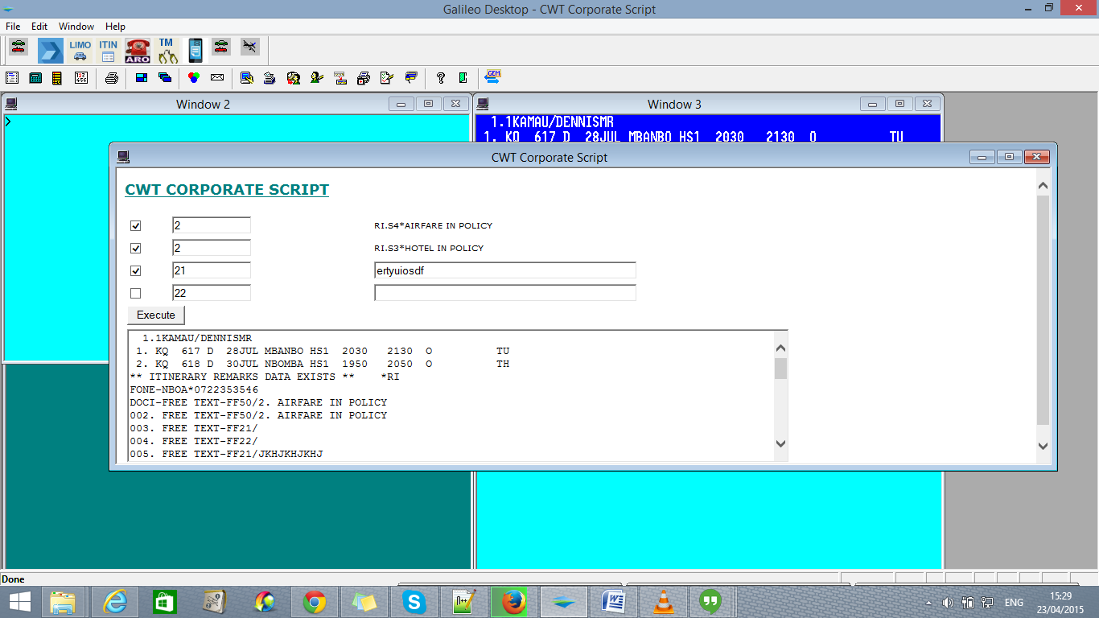

* It should also display any associated itinerary remarks

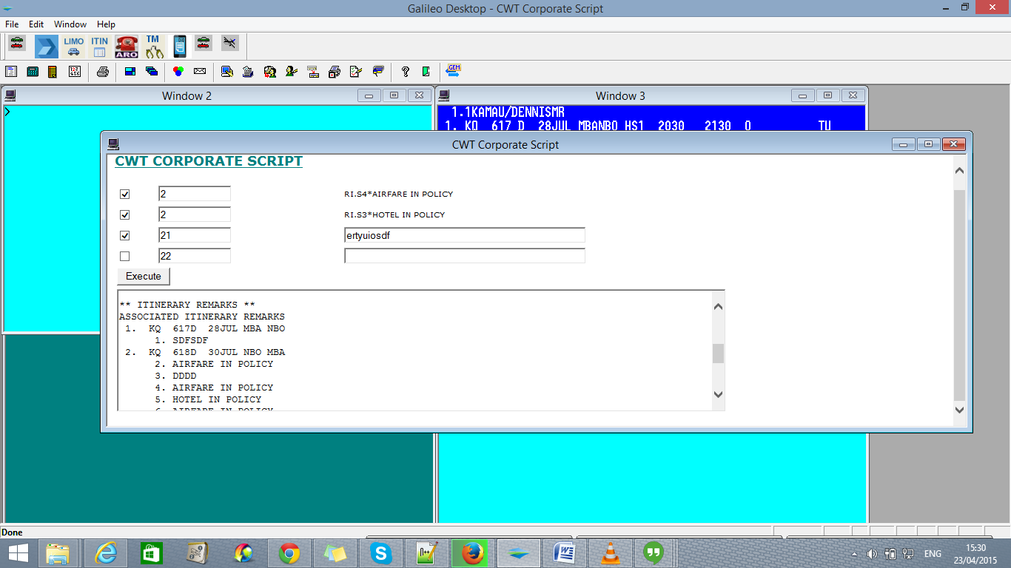

The script also is to give correct remark inserted in the script when generating a ticket. For example:-

* When  retrieving  PNR with  air segments  , remarks are corrected captured in the air segment party
* When retrieving PNRs with Air segment and Hotel segments, remarks are to be captured on the respective segments correctly. That is for the Air in policy it will be captured in the Air segment party while the hotel segment in Hotel in Policy it is captured in Hotel segments separately.